ANNOUNCING
A timely book by a prize-winning poet

Published by
Professor Emeritus John Lucas
at his celebrated
Shoestring Press

UK ORDERS:

Shoestring Press
19 Devonshire Avenue Beeston Nottinghamshire NG9 1BS
W: shoestringpress.co.uk
(cheques payable to
Shoestring Press)

ALL NON-UK ORDERS:
CLICK HERE
Central Books Ltd
Freshwater Road Dagenham
RM8 1RX England, UK
W: centralbooks.com E: orders@centralbooks.com T: 44 (0)845 458 9911

Typeset by Narrator typesetters & designers
W: narrator.me.uk
E: info@narrator.me.uk

Contact the author
Lynne Wycherley via:
E: emf@far-light.co.uk

THE TESTIMONY OF THE TREES
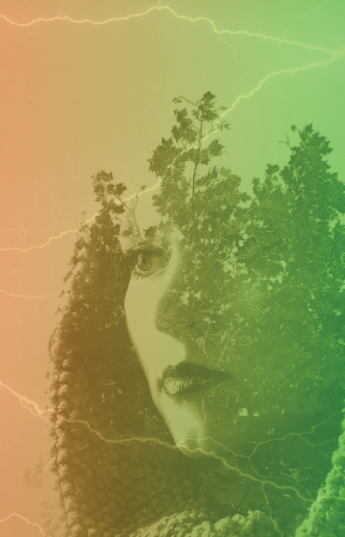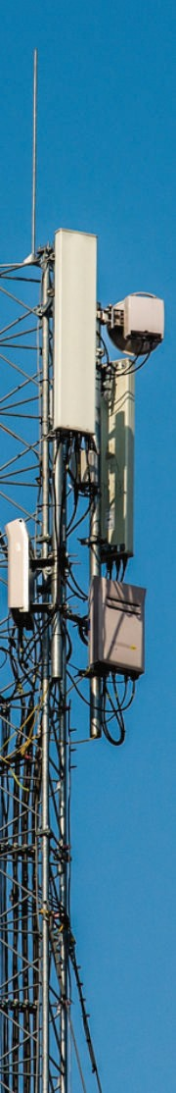By Lynne Wycherley
THE TESTIMONY
Lynne Wycherley
OF THE TREES

Now Available [2018]

£7.50 [+£1.50 postage]

ISBN: 978-1-912524-19-8

58 pages

Paperback, 135x210mm English

Following Listening to Light: new & selected poems, Lynne Wycherley’s new volume is a prayer for the living world in the face of dark digital trends. In an age increasingly swallowed up by wireless radiation, corporate greed, and addiction to small screens, embattled trees, children – and even DNA – shimmer with endangered beauty. Long known as a lyrical poet, and recently as a science writer, Wycherley has combined these aspects in her new collection, whose closing poems return us to the spiritual realm of nature that has always been close to her heart. Lynne is a health refugee living in Devon.

“In this inspiring collection, Lynne Wycherley paints pictures with words that capture the exquisite connections among living creatures and the dangers posed by the unprecedented rising sea of radiofrequency radiation. Her gift to the world, linking the smallest to the grandest, provides uplifting moments of reflection. If we are to create a healthier world for our children, we must set limits on how we use technology.” – Dr Devra Davis, Nobel prize laureate, President, The Environmental Health Trust

“Wycherley is a real Renaissance woman. Her poetry will wake you! She has the courage to ask the penetrating questions we should all be asking…” – Dr Olle Johansson, Professor Emeritus, Karolinska Institute

From reviews of her previous collections:

“A unique lyric sensibility… the poems alight on the page winged and true. Not since the work of Frances Horovitz has one heard such a voice” – Penelope Shuttle

“A compelling contribution to eco-poetry” – Peter Abbs, Resurgence

“A goal is held to with clarity of eye as well as the passion of a vision” – W N Herbert

