Published Peer Review Science on Risk of Cancers from Cellphone Use
Since 2011 when the International Agency for Research on Cancer (IARC), classified Radio Frequency Radiation (RFR) as a possible carcinogen.

Citations for all studies are in the Appendix

Epidemiology Studies on Cellphone Use
Brain cancer, 14 studies
United States (1), 5 Countries (1), 4 Countries (1), Sweden (6), Israel (1), Germany (1) France (1) 13 Countries (2)

Tumors of the meninges (meningioma), 6 studies
5 Counties (1), Israel (1), Sweden (3), France (1)

Hearing Nerve Tumor (vestibular Schwannoma; acoustic neuroma), 5 studies
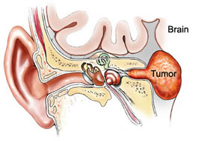
Israel (1), United Kingdom (1), Sweden (2), South Korea (1)

Parotid Gland Cancer (cheek salivary gland), 4 studies
Israel (3) Brazil (1), Saudi Arabia (1)
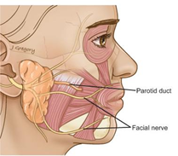

Eye Cancer (uveal melanoma), 4 studies
Germany (2), Israel (1), United States (1)

Breast Cancer (male & female), 4 studies
United States (2), Israel (1), China (1)

Skin melanoma, 3 studies
United States (1), Sweden (1) Israel (1)

Leukemia, 4 studies
Thailand (2), England (1), Israel (2)

Lymphoma, 2 studies
United States (1), Israel (1)

Thyroid Cancer, 4 studies
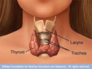

United States (3), Nordic Countries (1)

Multiple Cancers, 4 studies
Israel (3)
Large military study: <20 years 10%; 20-29 years, 33% ; 30-29 years, 14%, 40-49 years 20%; 50-59 years, 4%; 60-69 years 17%.
United States (1)
18 teachers diagnosed with cancers in small California middle school
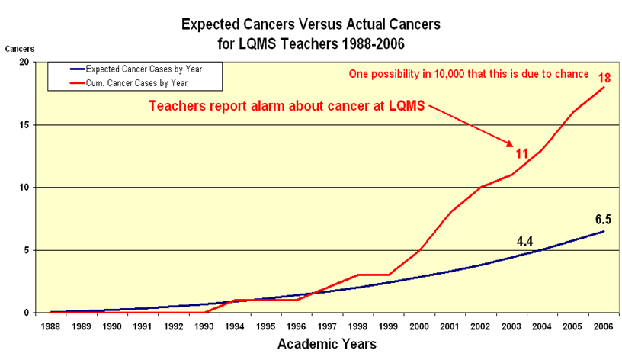

Two large animal studies (thousands of animals) from the United States and Italy confirmed each other’s findings.

In the United States, the National Toxicology Program (NTP) stated:
“Conclusions
In males for both GSM- and CDMA-modulated RFR, we conclude that exposures increased the number of animals with tumors in the heart. Tumors of the brain were also considered to be related to exposure; and increased numbers of male rats with tumors of the adrenal gland were also related to exposure. … This was also the case with female rats, where we conclude that exposure to GSM- or CDMA-modulated RFR may have been related to tumors in the heart. For females exposed to CDMA-modulated RFR, occurrences of brain and adrenal gland tumors may have been related to exposure.”

In Italy, the Ramazzini Institute (RI) used dramatically lower exposure compared to the NTP exposures.

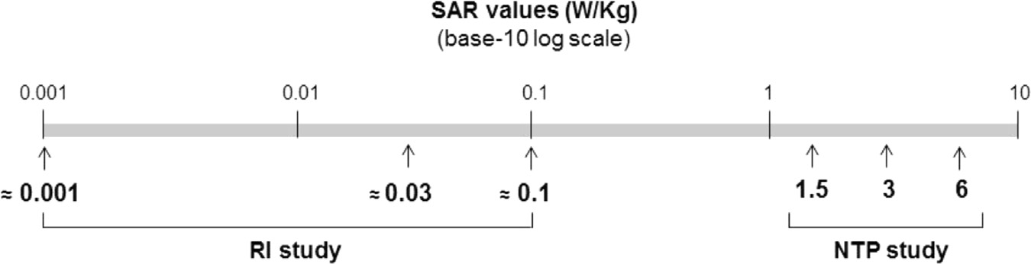

The difference was enormous, but their findings were nearly identical.

 | High SAR | Median SAR | Low SAR
NTP | 6.0 | 3.0 | 1.5
RI | 0.1 | ~0.03 | 0.001
Ratio NTP/RI | 60 | ~100 | 1,500

Many Corroboration Studies Have Been Published
Brain Absorption studies (2) and increasing Cancer Incidence Rate Studies (66) have been published.

Millimeter Wave Radiation (MWR), 5G
We all have heard about 5G (how could we miss it given the enormous advertising extravaganza). While we know ever little about the health effects, but what we do know is in itself alarming. 2G-GSM modulated, 3G-UMTS modulation, and 5G-MWR modulation radiation inhibits DNA repair genes. Once our DNA repair genes are inhibited we can expect increasing incidence rates of cancer.
What Is Modulation?
Electronic Engineers refer to a “carrier” frequency which when modulated, carries information by changing the carrier frequency.

Below is an image of the third generation (3G) UMTS modulated RFR where the carrier frequency is 0 Hz in the image below. 3G-UMTS modulation has 2,639 discrete frequencies of varying amplitude, ± 2.5 MHz from the carrier frequency.

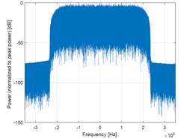
UMTS (3G) Modulation of Carrier Frequency

The number of discrete frequencies in 5G-modulated radiation is unknown, but will be very much larger that 3G-modulation. Discrete modulation can also create cancer. Studies have shown that 5G radiation inhibits DNA repair mechanisms, though research of MMW radiation is just beginning

Any single, or combinations of the discrete 5G modulation frequencies, can cause great harm but we will not know this until 5G has been in general use for at least a decade. Even after a decade only a small proportion of all the adverse effects will have been documented.

Appendix: Study Citations

Brain tumors

- Lehrer S, Green S, Stock RG. Association between number of cell phone contracts and brain tumor incidence in nineteen U.S. States. J Neurooncol. 2011 Feb;101(3):505-7
- Cardis E, Armstrong BK, Bowman JD, Giles GG, Hours M, Krewski D, McBride M, Parent ME, Sadetzki S, Woodward A, Brown J, Chetrit A, Figuerola J, Hoffmann C, Jarus-Hakak A, Montestruq L, Nadon L, Richardson L, Villegas R, Vrijheid M. Risk of brain tumours in relation to estimated RF dose from mobile phones: results from five Interphone countries. Occup Environ Med. 2011 Sep;68(9):631-40.
- INTERPHONE Study Group. Brain tumour risk in relation to mobile telephone use: results of the INTERPHONE international case-control study. Int J Epidemiol. 2010 Jun;39(3):675-94.
- Aydin D, Feychting M, Schüz J, Tynes T, Andersen TV, Schmidt LS, Poulsen AH, Johansen C, Prochazka M, Lannering B, Klæboe L, Eggen T, Jenni D, Grotzer M, Von der Weid N, Kuehni CE, Röösli M. Mobile phone use and brain tumors in children and adolescents: a multicenter case-control study. Natl Cancer Inst. 2011 Aug 17;103(16):1264-76.
- Hardell L, Carlberg M, Söderqvist F, Mild KH. Case-control study of the association between malignant brain tumours diagnosed between 2007 and 2009 and mobile and cordless phone use. Int J Oncol. 2013 Dec; 43(6):1833-45.
- Stein et al. A sentinel case series of cancer patients with occupational exposures to electromagnetic non-ionizing radiation and other agents. Eur. J. Oncol., vol. 16, n. 1, 2011.
- Carlberg M, Hardell L. On the association between glioma, wireless phones, heredity and ionising radiation. Pathophysiology. 2012 Sep;19(4):243-52.
- Carlberg & Hardell. Decreased survival of glioma patients with astrocytoma grade IV (glioblastoma multiforme) associated with long-term use of mobile and cordless phones. Int J Environ Res Public Health. 2014 Oct 16;11(10):10790-805.
- Akhavan-Sigari R, Mazloum Farsi Baf M, Ariabod V, Rohde V, Rahighi S. Connection between Cell Phone use, p53 Gene Expression in Different Zones of Glioblastoma Multiforme and Survival Prognoses. Rare Tumors. 2014 Aug 8;6(3):5350.
- Coureau G, Bouvier G, Lebailly P, Fabbro-Peray P, Gruber A, Leffondre K, Guillamo JS, Loiseau H, Mathoulin-Pélissier S, Salamon R, Baldi I. Mobile phone use and brain tumours in the CERENAT case-control study. Occup Environ Med. 2014 Jul;71(7):514-22.
- Hardell L, Carlberg M. Mobile phone and cordless phone use and the risk for glioma - Analysis of pooled case-control studies in Sweden, 1997-2003 and 2007-2009. Pathophysiology. 2015 Mar;22(1):1-13.
- Grell K, Frederiksen K, Schüz J, Cardis E, Armstrong B, Siemiatycki J, Krewski DR, McBride ML, Johansen C, Auvinen A, Hours M, Blettner M, Sadetzki S, Lagorio S, Yamaguchi N, Woodward A, Tynes T, Feychting M, Fleming SJ, Swerdlow AJ, Andersen PK. The Intracranial Distribution of Gliomas in Relation to Exposure From Mobile Phones: Analyses From the INTERPHONE Study. Am J Epidemiol. 2016 Nov 3.
- de Vocht F. Inferring the 1985-2014 impact of mobile phone use on selected brain cancer subtypes using Bayesian structural time series and synthetic controls. Environ Int. 2016 Nov 8; 97:100-107.
- Carlberg M, Koppel T, Ahonen M, Hardell L. Case-control study on occupational exposure to extremely low-frequency electromagnetic fields and glioma risk. Am J Ind Med. 2017 May;60(5):494-503.
- Carlberg M, Hardell L. Evaluation of Mobile Phone and Cordless Phone Use and Glioma Risk Using the Bradford Hill Viewpoints from 1965 on Association or Causation. Biomed Res Int. 2017;2017:9218486.

Tumors of the Meninges (Meningioma), which surrounds the brain and spinal cord

- Cardis E, Armstrong BK, Bowman JD, Giles GG, Hours M, Krewski D, McBride M, Parent ME, Sadetzki S, Woodward A, Brown J, Chetrit A, Figuerola J, Hoffmann C, Jarus-Hakak A, Montestruq L, Nadon L, Richardson L, Villegas R, Vrijheid M. Risk of brain tumours in relation to estimated RF dose from mobile phones: results from five Interphone countries. Occup Environ Med. 2011 Sep;68(9):631-40.
- Stein et al. A sentinel case series of cancer patients with occupational exposures to electromagnetic non-ionizing radiation and other agents. Eur. J. Oncol., vol. 16, n. 1, 2011.
- Carlberg M, Söderqvist F, Hansson Mild K, Hardell L. Meningioma patients diagnosed 2007-2009 and the association with use of mobile and cordless phones: a case-control study. Environ Health. 2013 Jul 19;12(1):60.
- Coureau G, Bouvier G, Lebailly P, Fabbro-Peray P, Gruber A, Leffondre K, Guillamo JS, Loiseau H, Mathoulin-Pélissier S, Salamon R, Baldi I. Mobile phone use and brain tumours in the CERENAT case-control study. Occup Environ Med. 2014 Jul;71(7):514-22.
- Carlberg M, Hardell L. Pooled analysis of Swedish case-control studies during 1997-2003 and 2007-2009 on meningioma risk associated with the use of mobile and cordless phones. Oncol Rep. 2015 Jun;33(6):3093-8.
- Carlberg M, Hardell L. Pooled analysis of Swedish case-control studies during 1997-2003 and 2007-2009 on meningioma risk associated with the use of mobile and cordless phones. Oncol Rep. 2015 Jun;33(6):3093-8.

Hearing Nerve Tumor (vestibular Schwannoma; acoustic neuroma)

- Stein et al., A sentinel case series of cancer patients with occupational exposures to electromagnetic non-ionizing radiation and other agents. Eur. J. Oncol., vol. 16, n. 1, 2011.
- Benson VS, Pirie K, Schüz J, Reeves GK, Beral V, Green J; Mobile phone use and risk of brain neoplasms and other cancers: prospective study. Int J Epidemiol. 2013 Jun;42(3):792-802.
- Hardell L, Carlberg M, Söderqvist F, Mild KH. Pooled analysis of case-control studies on acoustic neuroma diagnosed 1997-2003 and 2007-2009 and use of mobile and cordless phones. Int J Oncol. 2013 Oct;43(4):1036-44.
- Moon IS, Kim BG, Kim J, Lee JD, Lee WS. Association between vestibular schwannomas and mobile phone use. Tumour Biol. 2014 Jan;35(1):581-7.
- Pettersson D, Mathiesen T, Prochazka M, Bergenheim T, Florentzson R, Harder H, Nyberg G, Siesjö P, Feychting M. Long-term mobile phone use and acoustic neuroma risk. Epidemiology. 2014 Mar;25(2):233-41.

Parotid Gland Cancer (a large salivary gland in the cheeks)

- Goldwein O, Aframian DJ. The influence of handheld mobile phones on human parotid gland secretion. Oral Dis. 2010 Mar;16(2):146-50.
- Czerninski, Rakefet; Zini, Avi; Sgan-Cohen, Harold D. Risk of Parotid Malignant Tumors in Israel (1970–2006). Epidemiology: January 2011 - Volume 22 - Issue 1 - pp 130–131.
- Stein et al. A sentinel case series of cancer patients with occupational exposures to electromagnetic non-ionizing radiation and other agents. Eur. J. Oncol., vol. 16, n. 1, 2011.
- de Siqueira EC, de Souza FT, Gomez RS, Gomes CC, de Souza RP. Does cell phone use increase the chances of parotid gland tumor development? A systematic review and meta-analysis. J Oral Pathol Med. 2016 Dec 9.
- Shu X. Ahlbom A. Feychting M. Incidence trends of malignant parotid gland tumor in Swedish and Nordic adults 1970 to 2009. Epidemiology 2012;23(5):766-7.

Eye Cancer (uveal melanoma, choroid tumur, ocular melanoma)

- Stang et al. The Possible Role of Radiofrequency Radiation in the Development of Uveal Melanoma. Epidemiology. 2001 Jan;12(1):7-12.
- Behrens T, Lynge E, Cree I, Sabroe S, Lutz JM, Afonso N, Eriksson M, Guénel P, Merletti F, Morales-Suarez-Varela M, Stengrevics A, Févotte J, Llopis-González A, Gorini G, Sharkova G, Hardell L, Ahrens W. Occupational exposure to electromagnetic fields and sex-differential risk of uveal melanoma. Occup Environ Med. 2010 Nov;67(11):751-9.
- Stein et al., A sentinel case series of cancer patients with occupational exposures to electromagnetic non-ionizing radiation and other agents. Eur. J. Oncol., vol. 16, n. 1, 2011.
- Milham S, Stetzer D. Tumor-specific frequencies and ocular melanoma. Electromagn Biol Med. 2016 Aug 23:1–5.

Cancers of the Breast (male and female)

- Milham S, Morgan LL. A new electromagnetic exposure metric: high frequency voltage transients associated with increased cancer incidence in teachers in a California school. Am J Ind Med. 2008 Aug;51(8):579-86.
- Stein et al., A sentinel case series of cancer patients with occupational exposures to electromagnetic non-ionizing radiation and other agents. Eur. J. Oncol., vol. 16, n. 1, 2011.
- West JG, Kapoor NS, Liao SY, Chen JW, Bailey L, Nagourney RA. “Multifocal Breast Cancer in Young Women with Prolonged Contact between Their Breasts and Their Cellular Phones.” Case Rep Med. 2013;2013:354682.
- Sun JW, Li XR, Gao HY, Yin JY, Qin Q, Nie SF, Wei S. Electromagnetic field exposure and male breast cancer risk: a meta-analysis of 18 studies. Asian Pac J Cancer Prev. 2013;14(1):523–8.
Melanoma of the Skin
- Milham S, Morgan LL. A new electromagnetic exposure metric: high frequency voltage transients associated with increased cancer incidence in teachers in a California school. Am J Ind Med. 2008 Aug;51(8):579–86.
- Hardell L, Carlberg M, Hansson Mild K, Eriksson M. Case-control study on the use of mobile and cordless phones and the risk for malignant melanoma in the head and neck region. Pathophysiology. 2011 Sep;18(4):325–33.
- Stein et al., A sentinel case series of cancer patients with occupational exposures to electromagnetic non-ionizing radiation and other agents. Eur. J. Oncol., vol. 16, n. 1, 2011.
Leukemia

- Kaufman DW, Anderson TE, Issaragrisil S. Risk factors for leukemia in Thailand. Ann Hematol. 2009 Nov;88(11):1079–88.
- Cooke R, Laing S, Swerdlow AJ. A case-control study of risk of leukaemia in relation to mobile phone use. Br J Cancer. 2010 Nov 23;103(11):1729-35.
- Stein et al. A sentinel case series of cancer patients with occupational exposures to electromagnetic non-ionizing radiation and other agents. Eur. J. Oncol., vol. 16, n. 1, 2011.

Thyroid Cancer (male and female)

- Milham S, Morgan LL. A new electromagnetic exposure metric: high frequency voltage transients associated with increased cancer incidence in teachers in a California school. Am J Ind Med. 2008 Aug;51(8):579-86.
- Carlberg M, Hedendahl L, Ahonen M, Koppel T, Hardell L. Increasing incidence of thyroid cancer in the Nordic countries with main focus on Swedish data. BMC Cancer. 2016 Jul 7;16:426.
- Lim H, Devesa SS, Sosa JA, Check D, Kitahara CM. Trends in Thyroid Cancer Incidence and Mortality in the United States, 1974-2013. JAMA. 2017 Apr 4;317(13):1338-1348.
- Luo J, Deziel NC, Huang H, Chen Y, Ni X, Ma S, Udelsman R, Zhang Y. Cell phone use and risk of thyroid cancer: a population-based case-control study in Connecticut. Ann Epidemiol. 2018 Oct 29.

Multiple Cancers

- Peleg M. Report on a Cancer Cluster in an Antenna Ranges Facility. IEEE COMCAS 2009 conference, Tel-Aviv, 9-11 Nov. 2009.
- Milham S, Morgan LL. A new electromagnetic exposure metric: high frequency voltage transients associated with increased cancer incidence in teachers in a California school. Am J Ind Med. 2008 Aug;51(8):579-86.
In addition to the cancers reported above (uterine, non-Hodgkin’s lymphoma, polycythemia vera, amyloidosis, leiomyosarcoma, colon, pancreatic and ovarian.
- Stein et al. A sentinel case series of cancer patients with occupational exposures to electromagnetic non-ionizing radiation and other agents. Eur. J. Oncol., vol. 16, n. 1, 2011.
In addition to the cancers reported above (ALL leukemia, AML leukemia, T-cell leukemia, Hodgkin’s lymphoma, Non-Hodgkin[s lymphoma, bone cancer, pineal gland, colon, rectal, testicular, lung, hairy cell leukemia, liver, plasmacytoma, squamous cell, Ewings’s sarcoma, prostate and renal cell.

NTP TR595, page 8.
SAR: Specific Absorption Rate

